#include <iostream>

using namespace std;

class tire

{

friend class car;

private:

double pressure;//气压

double d;

public:

double addpressure(double setPressure);//加气

};

class engine

{

friend class car;

private:

double n;//转速

double size;//油门

public:

double burnOil(double oil);//oil-k\*size，模拟烧油

};

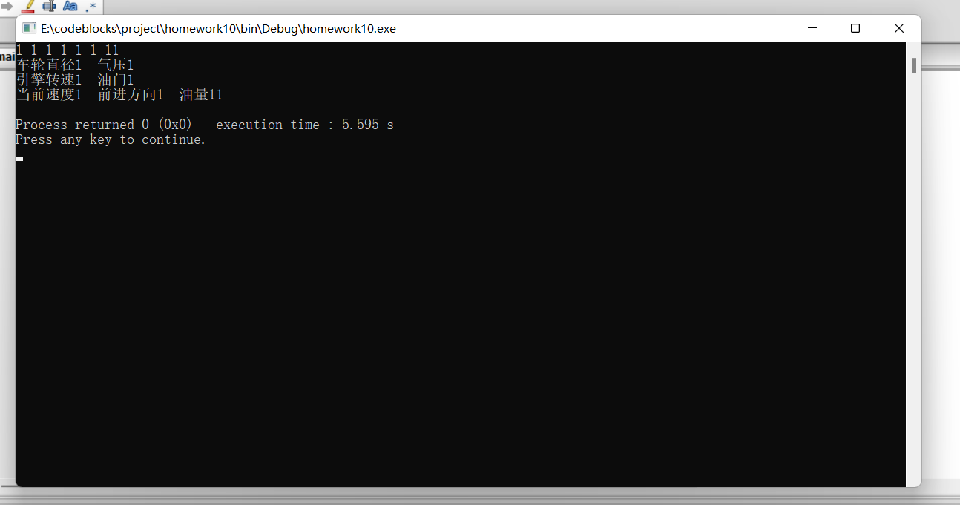

//成功建立的截图

class car

{

private:

tire t1,t2,t3,t4;//四个轮胎

engine obj;//引擎

double speed;//当前速度

double angle;//前轮与x轴正方向所成角

double oil;//油量

public:

car(double d,double p,double n,double size,//d直径，p气压，n转速，size油门

double spd,double drc,double amount) //spd速度，drc方向,amount油量

{

t1.d=d,t1.pressure=p,t2.d=d,t2.pressure=p,

t3.d=d,t3.pressure=p,t4.d=d,t4.pressure=p,

speed=spd,angle=drc,oil=amount,

obj.n=n,obj.size=size;

cout<<"车轮直径"<<d<<" "<<"气压"<<p<<endl;

cout<<"引擎转速"<<n<<" "<<"油门"<<size<<endl;

cout<<"当前速度"<<spd<<" "<<"前进方向"<<drc

<<" "<<"油量"<<amount<<endl;

}

double accelerate(double setSpeed);//输入，加速或减速;事先显示当前速度

double addoil(double add);//输入，加油（可是加油不应该是加油站馆的吗）

double turn(double setAngle);//输入，改角度;事先显示当前方向

};

int main()

{

double d,p,n,size,spd,drc,amount;

cin>>d>>p>>n>>size>>spd>>drc>>amount;

car car1(d,p,n,size,spd,drc,amount);

}